Start Date: 21/11/06

URL:

Proposal: Create a compact Neural network that performs just as good or better than Deep/Shallow Conv Nets

**Summary**

This paper proposed a CNN network called EEGNEt which is compact then general CNNs. This is tested over 4 paradigms

1. P300 visual evoked potentials
2. Error Negativity Responses (ERN)
3. Movement related cortical potentials (MRCP)
4. Sensory motor rhythms (SMR)

EEGNet seems to perform better across the paradigms than reference algorithms(DeepConvNet and ShallowConvNet) when limited data is available.

Introduction of depthwise and Separable Convolutions.

For EEG signal classification.

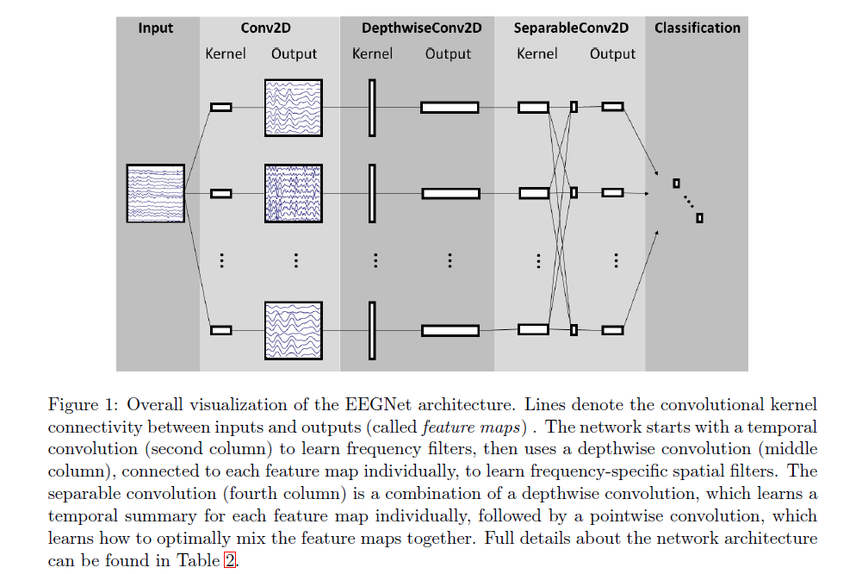

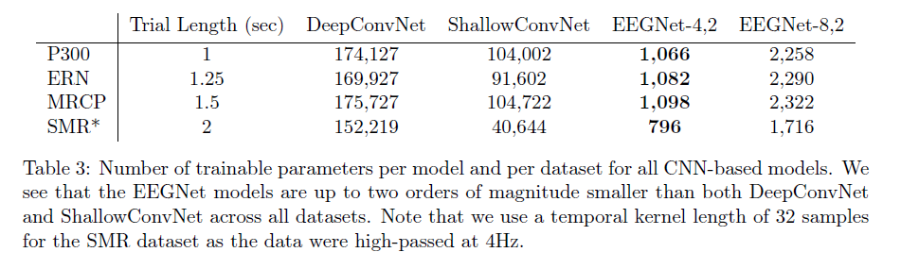

Conclusion

- EEGNet is a compact CNN that performs better than reference algorithms

- EEGNEt seems to be not driven by noise and artifcacts.

- Understanding the features within the network is a challenging task.

End: 03/11/21"